Multimedia Development Lab 1
ADOBE PHOTOSHOP
WEEK_03

Practice Session 3.1 - Color & Tonal Adjustments

Try and change the color of the garment in the image below with different types of retouching commands. These commands help in advance photo retouching after proper practice.
1. Open an image. Select the shirt with Pen tool.
2. Image > Adjust > Color Balance etc. OR in layer palette create an adjustment layer with selected option for color & tonal adjustments.
 | 
Original Image | Color Levels:100 -100 0  Tone Balance : Midtone
 | 
ColorLevels : 100 0 0  Tone Balance : Midtone | Color Levels : 100 0 0  Tone Balance : Midtone

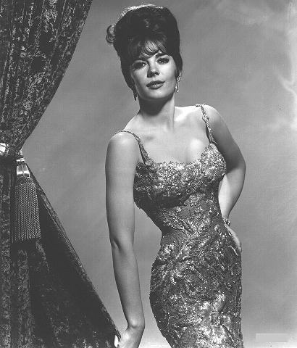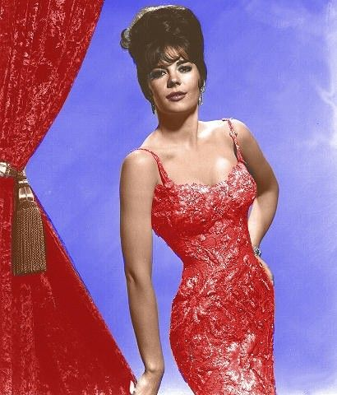

Today’s exercise (Lab03b) Colorize a grayscale image: Take a grayscale image from the sample Images.
Methodology: Covert color mode to RGB, Select areas to be colorized, Try all the options –Image > Adjustment > Levels, color balance, hue & saturation etc. to colorize the image.
Practice Session 3.2 - Clone Stamp Tool
Cloning the wall at the back of the image to remove lady standing in front.
The Clone stamp tool allows you to paint with a sample of an image.
Keep in mind that you are not healing/repairing an image when you use the Clone Stamp Tool. Therefore, lighting and shading will not be maintained when you paint over an area. What you see is literally what you get when you paint from a given source, making it very useful in certain situations. (Take clone stamp tool, press alt to pick sample to clone, paint with the sample).
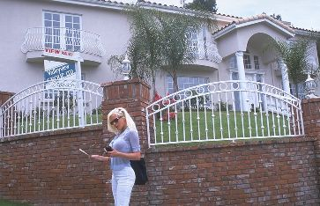 | 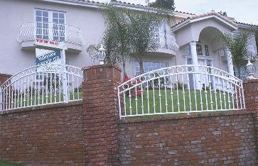
Valley view before | Valley view after

Today’s exercise (Lab03b) Clone the required area of the image (given as per your batch in the sample Images).

